## Plan Stages

Several phases of works at one location can now be included in a single traffic plan, using the Plan Stages feature.

Each plan stage has its own set of layers and print regions, while the base layer is used for elements shared across all the other stages (e.g., road network, permanent markings).

## Setting up plan stages

Selecting the **Enable plan stages** button will activate Plan stages on the layer you currently have selected.

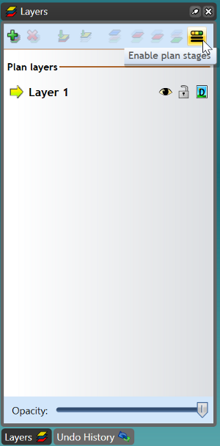

Enable_Plan_Stages

When you have enabled the Plan stages on a particular layer, your layers tab will be separated into **Stage** layers and **Base** layers.

The **Base** layers are where all of the permanent road objects, signs and markings will be displayed. The **Stage** layers are used for showing objects in different phases. For example, you can have one base layer with two stage layers - daytime setup and nighttime setup.

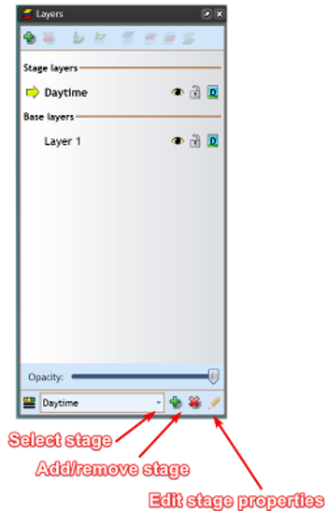

Plan_Stages_Options

**Select stage** allows you change between your different stages. **Add/remove stage** allows you to create new stages with the click of a button. It also remove stages, if necessary. **Edit stage properties** allows you to name the stage and attach specific comments to it.